**DAILY ONLINE ACTIVITIES SUMMARY**

|  |  |  |  |  |  |  |  |
| --- | --- | --- | --- | --- | --- | --- | --- |
| **Date:** | **21-05-2020** | | | | **Name:** | **Gudugunti Anirudh** | |
| **Sem & Sec** | **IV - A** | | | | **USN:** | **4al18cs023** | |
| **Online Test Summary** | | | | | | | |
| **Subject** | | MICROCONTROLLER AND EMBEDDED SYSTEMS | | | | | |
| **Max. Marks** | | **30** | | **Score** | | **22** | |
| **Certification Course Summary** | | | | | | | |
| **Course** | **Python in ML** | | | | | | |
| **Certificate Provider** | | | **Great learning academy** | **Duration** | | | **2hrs** |
| **Coding Challenges** | | | | | | | |
| **Problem Statement:** 1. To demonstrate the process of SRTF scheduling  2. To remove duplicate elements from a SLL | | | | | | | |
| **Status: Uploaded** | | | | | | | |
| **Uploaded the report in Github** | | | | **Yes** | | | |
| **If yes Repository name** | | | | **https://github.com/Anirudh23-23/Daily-progress** | | | |
| **Uploaded the report in slack** | | | | **Yes** | | | |

Online Test Details: The online test was from module 1. There were 30 MCQ and the duration were 30 minutes. The questions were optimal. The score that I received was 22/30.

Snapshot:

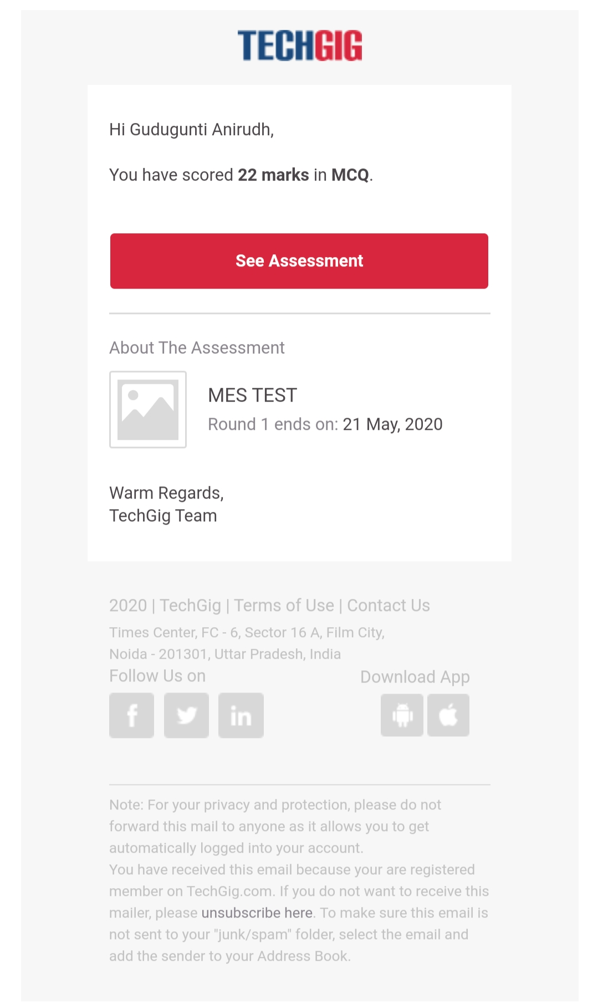

Certification Course Details:

1. Data structures in python.

2. Detailed instructions on data structures of python.

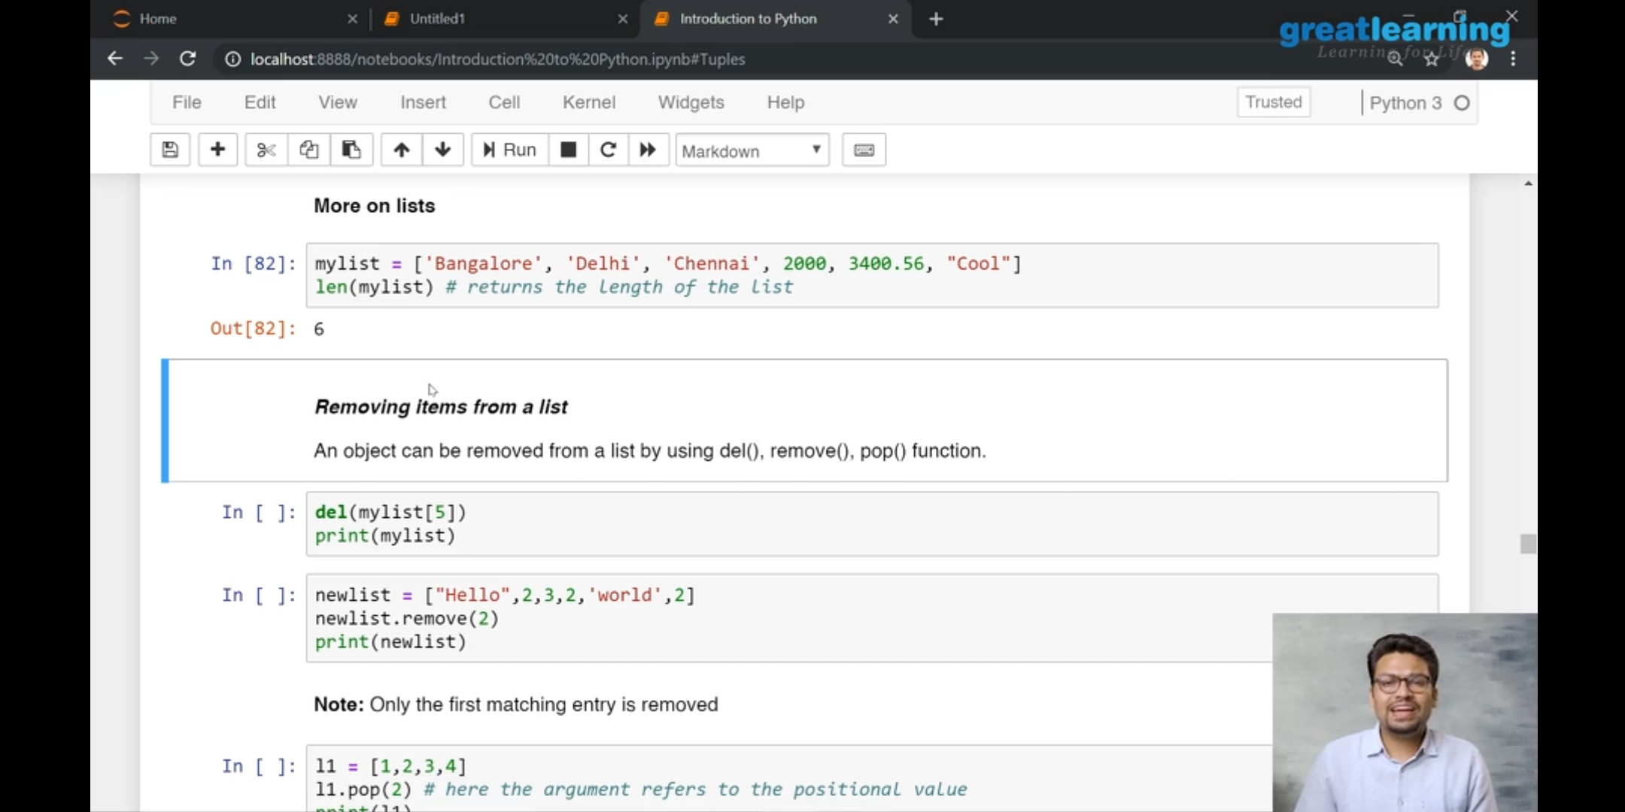

3. Instructions on how to remove,insert into a list,tuple, dictionaries.

Coding Challenges Details:

Problem 1: (using C language) Write a program to demonstrate SRTF(Shortest Remaining Time First) scheduling process.

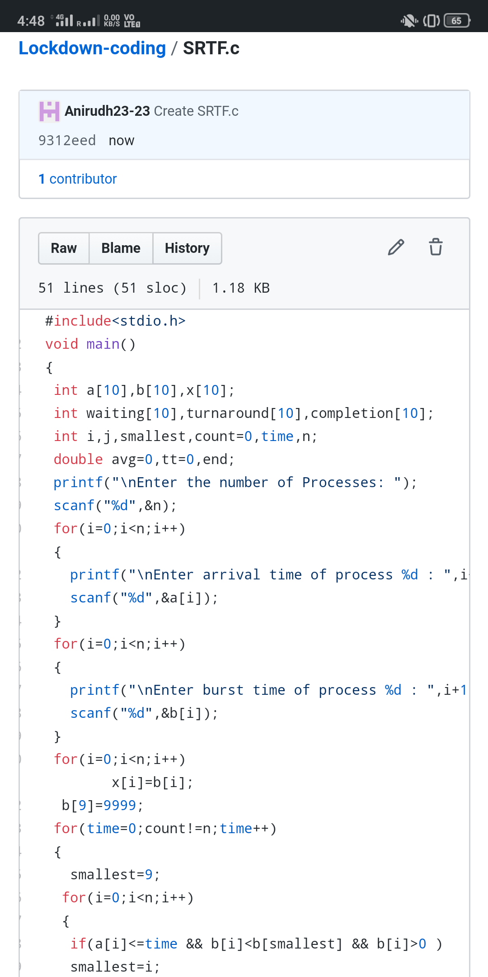

Problem 2: (Using C) Write a program to remove duplicate elements from a singly linked list.

